Bonding & Structure Practical - Part i

Aim: to test a variety of substances to see whether they have simple molecular or giant structures. |  | Materials required  - Ignition tubes  - Substances A - F  - tongs
Information:
- In most non-metal elements, the atoms are joined together in small groups called molecules. These exist as simple molecular structures.
- All metals, a few non-metallic elements and all ionic compounds are giant structures.
- Molecular substances have low melting points.
- Giant structures have high melting points.

What to do:
- Place a ¼ spatula of the substance to be tested in an ignition tube.
- Record the appearance of the sample before heating.
- Heat the sample, first gently then more strongly.
- Note whether the m.pt. is high (doesn’t melt) or low (melts easily)
- Repeat the experiment with other samples.

Record your results into the table provided on worksheet 8b(iii)
Unknown samples may be hazardous, so be careful
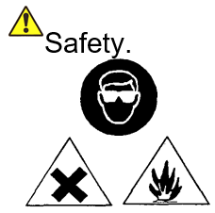

Sample F must only be heated in a fume cupboard.

Analysis of your results:
Look to see how easily the substances melt or evaporate. This will tell you about the strength of the forces between the atoms or molecules.
1. Are the forces between molecules in a molecular structure weak or strong?

2. Are the forces between the atoms or ions in a giant structure weak or strong?

3 .Look at your results (in column 3) and decide which of the substances you have tested is molecular and which have giant structures. Fill your answer into column 4 of worksheet 8b(iii)

